**Introduction to Databases (Spring 2020)**

**Homework #3 (50 Pts, May 20, 2020)**

**Student ID 2016312761**

**Name 여혁수**

**(1) [10 pts]** Consider the relation 𝑅 = {𝐴, 𝐵, 𝐶, 𝐷, 𝐸, 𝐹, 𝐺, 𝐻, 𝐼, 𝐽} and a set of the set of functional dependencies {𝐴𝐵 → 𝐶, 𝐴 → 𝐷𝐸, 𝐵 → 𝐹, 𝐹 → 𝐺𝐻, 𝐷 → 𝐼𝐽}.

**(a) [2 pts]** What is the key for the relation R?

# Answer

|  |
| --- |
| **A,B because these decide all other attributes.** |

**(b) [4 pts]** Decompose the relation R into 2NF relations.

# Answer

|  |
| --- |
| **{A,D,E,I,J }, {AB,C}, {B,F,G,H}, because 2NF is separated by primary keys and related FD.** |

**(c) [4 pts]** Decompose the relation R into 3NF relations.

# Answer

|  |
| --- |
| **{A,D,E}, {A,B,C}, {B,F}, {F,G,H}, {D,I,J}** |

**(2)** [**10 pts**] Choose all functional dependencies for the following relation.

|  |  |  |
| --- | --- | --- |
| **A** | **B** | **C** |
| 1 | 2 | 1 |
| 1 | 1 | 2 |
| 2 | 3 | 1 |
| 2 | 1 | 2 |

(a) 𝐶 → 𝐵 (b) 𝐶 → 𝐴 (c) 𝐴 → 𝐵

(e) 𝐵𝐶 → 𝐴 (e) 𝐴𝐶 → 𝐵 (f) 𝐴𝐵 → 𝐶

# Answer

(e) AC-> B, and (f) AB-> C are functional dependencies of this relation.

**(3) [10 pts]** Suppose that we have a relation 𝑅(𝐴, 𝐵, 𝐶, 𝐷). For each of the following sets of FDs, identify all possible key(s) for R (**5 pts each**).

**(a)** 𝐵 → 𝐶, 𝐷 → 𝐴

# Answer

|  |
| --- |
| **{B,D} is minimal superkey of this relation.** |

**(b)** AB𝐶 → 𝐷, 𝐷 → 𝐴

# Answer

|  |
| --- |
| **{A,B,C} , {B,C,D} are possible cases of minimal superkey.** |

**(4)** [**10 pts**] Consider the relation 𝐄𝐦𝐩𝐥𝐨𝐲𝐞𝐞(𝑒𝑛𝑜, 𝑒𝑛𝑎𝑚𝑒, 𝑝𝑛𝑜, 𝑝𝑛𝑎𝑚𝑒, 𝑔𝑟𝑎𝑑𝑒, 𝑗𝑜𝑏, 𝑐ℎ𝑎𝑟𝑔𝑒, ℎ𝑜𝑢𝑟) with the primary key {𝑒𝑛𝑜, 𝑝𝑛𝑜, 𝑔𝑟𝑎𝑑𝑒}. There are the following functional dependencies.

* {𝑒𝑛𝑜} → {𝑒𝑛𝑎𝑚𝑒, 𝑗𝑜𝑏}
* {𝑝𝑛𝑜} → {𝑝𝑛𝑎𝑚𝑒}
* {𝑒𝑛𝑜, 𝑝𝑛𝑜} → {ℎ𝑜𝑢𝑟}
* {𝑗𝑜𝑏} → {𝑐ℎ𝑎𝑟𝑔𝑒}

Decompose the relations using BCNF. Specify a primary key for each relation.

We can normalize to {eno, ename, job}, {eno, pno, hour}, {pno, pname}, {eno, pno, grade}, {job, charge}

# Answer

**(5)** [**10 pts**] The following set of data represents a sample of the types of data used by a clerk in a library. Suppose every author who wrote the books in the library has a different name. Apply normalization until you cannot decompose the relations further.

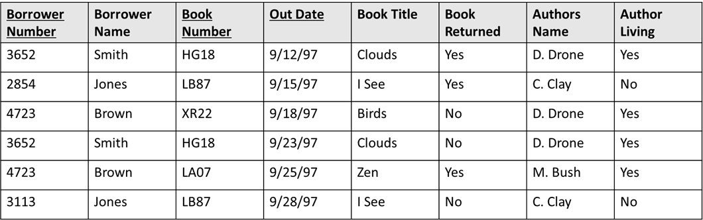

# Answer

|  |
| --- |
| **To make primary keys are BorrowNumber, BookNumber, OutDate, we should normalize like this.**  **{BorrowerNumber, BorrowerName}**  **{BorrowerNumber, BookNumber, OutDate, BookReturned}-> Attribute Outdate can become primary key element.**  **{AuthorsName, AuthorLiving}**  **{BookNumber, BookTitle, AuthorsName}** |